
This is simple grid game in C#, two players have to navigate through a grid and pick up items without bumping into obstacles. The game ends when a player runs into an obstacle (loss) or has picked up all items (win).
Configuring the Game
The game logic of the core game is within the Game class. The class handles user input, manages the game loop, sets up the game, and updates the game state. Key features are the fields, where the game area is represented by the grid grid. The two players are Player Player1 and Player Player2, and the game loop management by bool is Running; bool player1Turn maintains whose turn it is.The methods Start() begins the game and executes the instructions to be rendered in the main game loop.ShowInstructions() displays the game objectives and controls of the game.HandleInput() utilizes keyboard input to discern player movements.

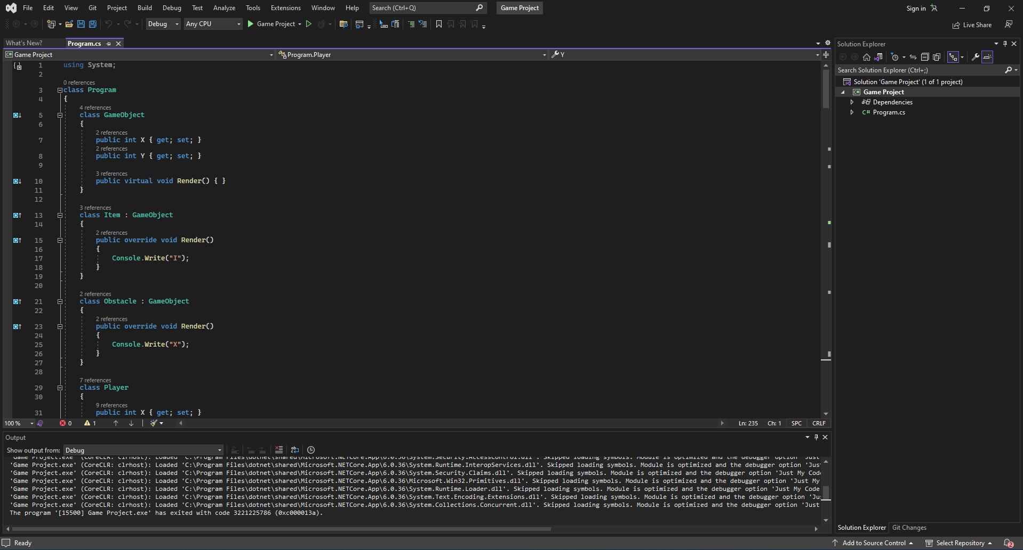

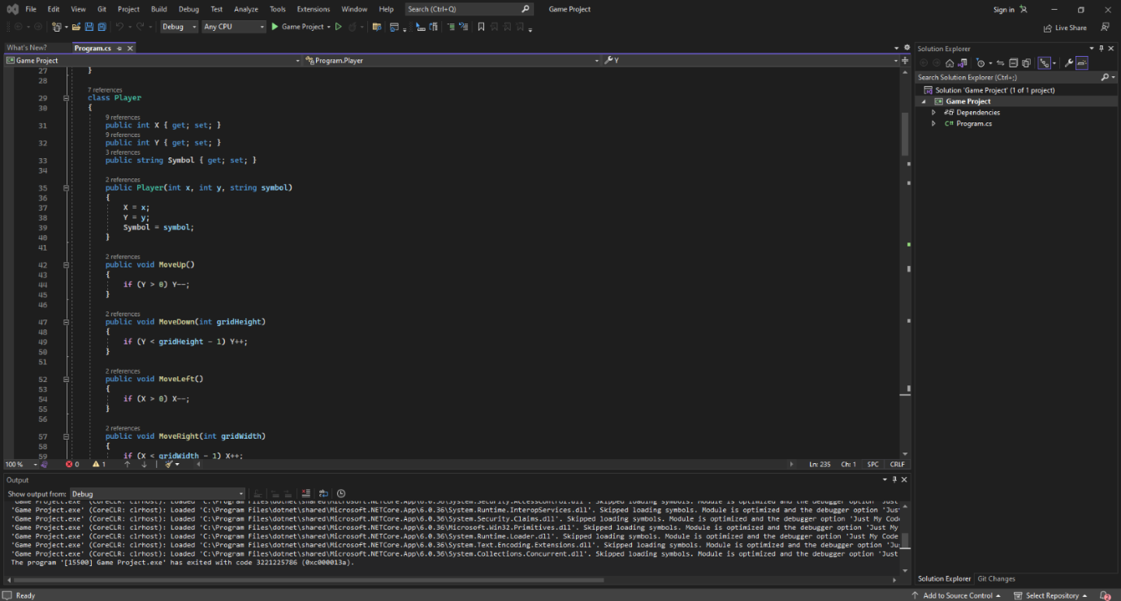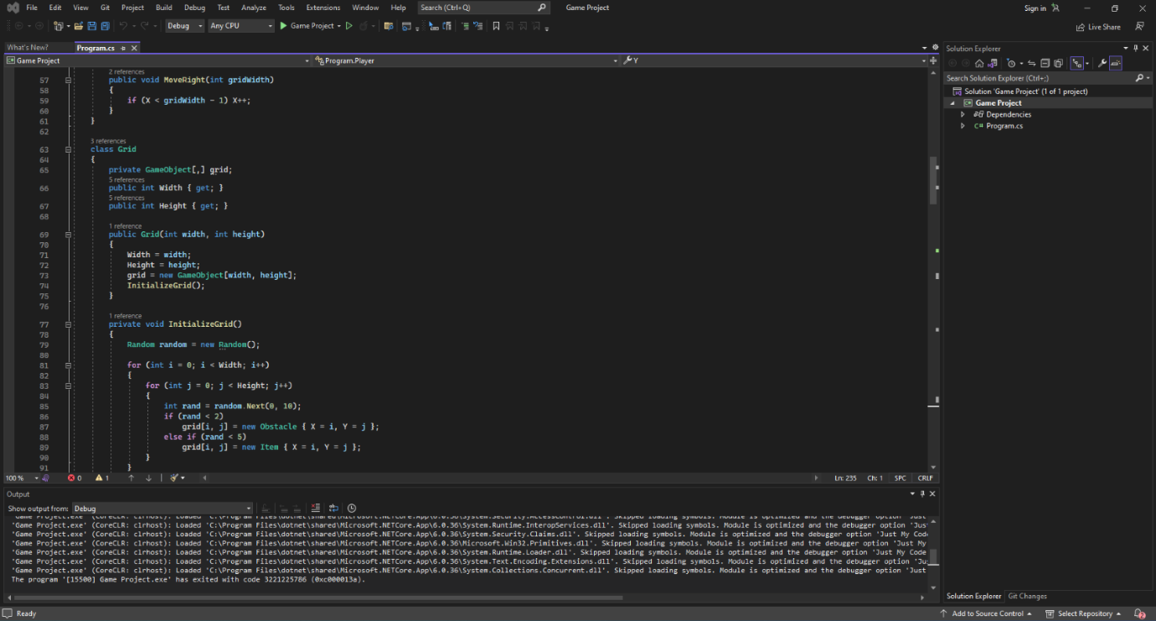

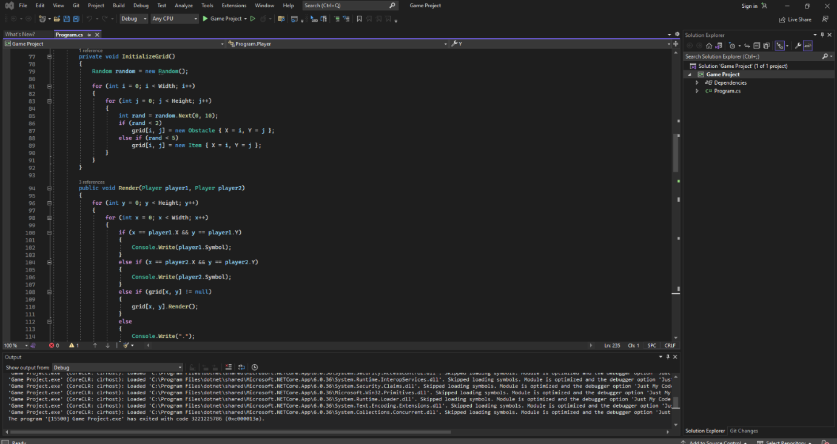
Class of player
A player in the game is represented by the player class.
where the player's position on the grid is tracked by Properties X and Y. On the grid, the symbol stands in for the player's character.MoveUp(), MoveDown(), MoveLeft(), and MoveRight() are the game's methods that modify the player's position while making sure they remain inside the grid.
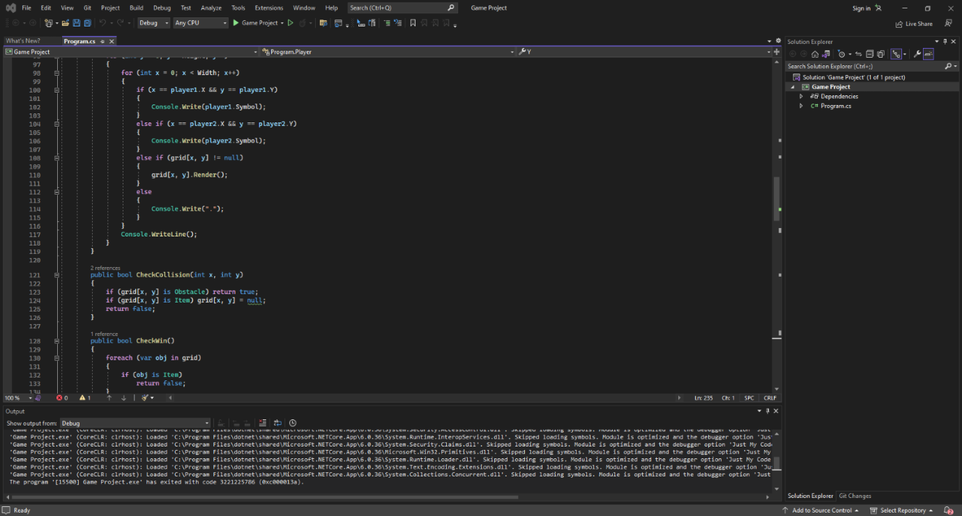
Class of Grid
The Grid class represents the game space.The Fields GameObject[,] grid's location GameObject objects (obstacles and items) are stored in a 2D array.Height and Width specify the dimensions of the grid. The methods Items (I) and obstacles (X) are randomly placed on the grid by InitializeGrid(). The grid, objects, and players are drawn by Render().CheckCollision() is responsible for checking whether the player has collected an item or collided with a wall. CheckWin() checks whether all the items have been picked up.
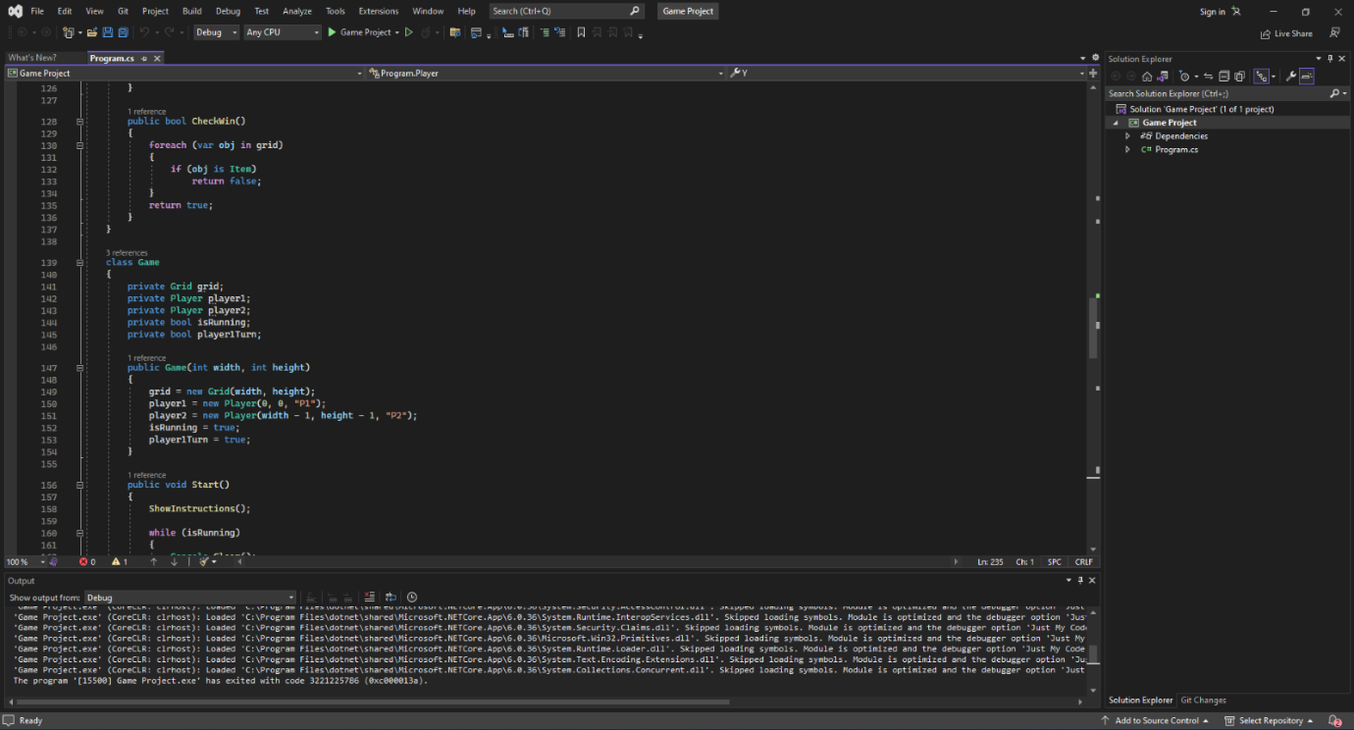
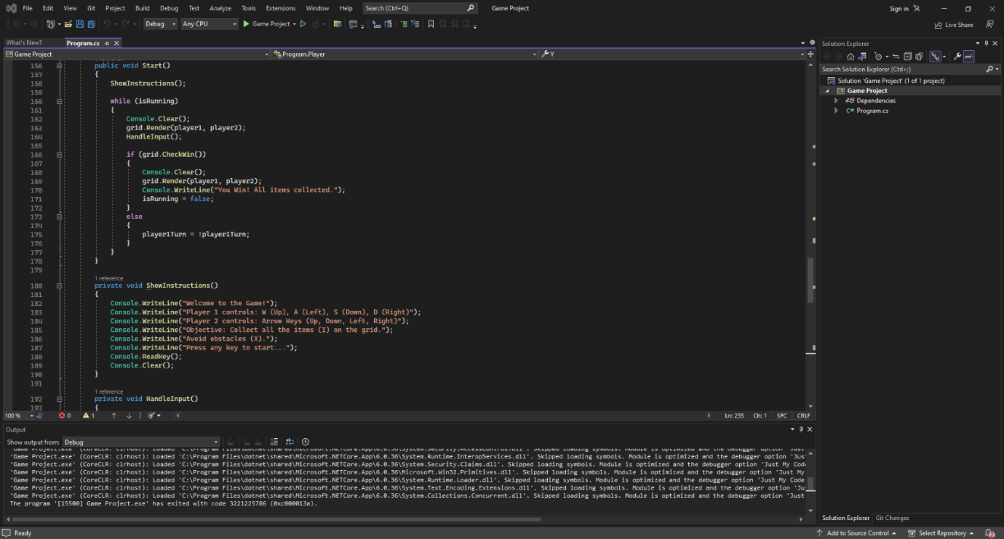
Items in the Game
The basic class of game objects is GameObject. Properties in this game where X and Y track the position of the object. The methods of this game are The object is drawn on the grid with Render().Collectible objects are defined by inheriting classes tem (represented by I).
Obstacles in this game are represented by the character X.
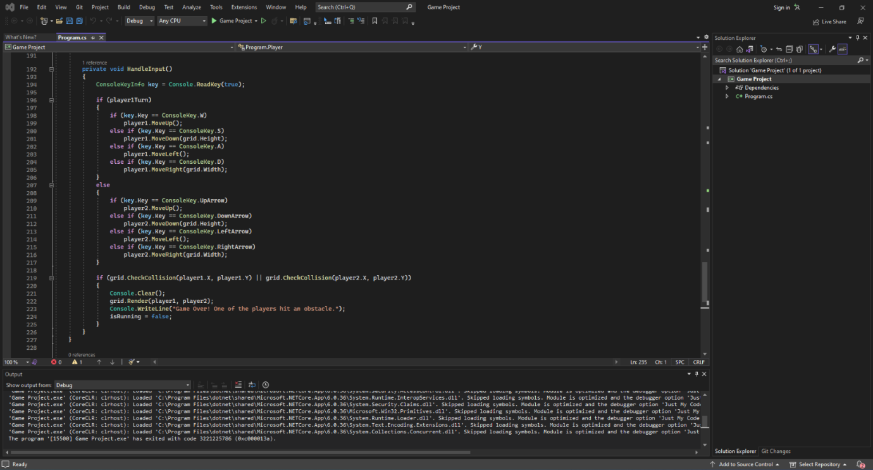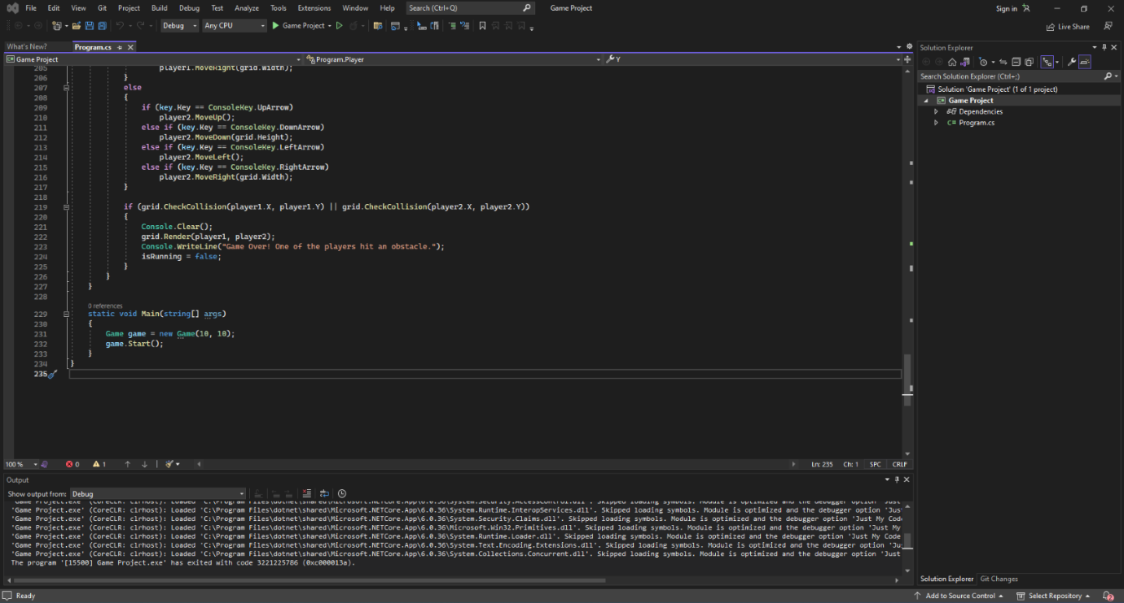

The following is typically performed by the game loop in the Game class: clears the terminal, renders players and grid, handles player movement from human input.updates game state winning conditions or collision check.Winning and Losing Conditions.Where to Win All the items are picked up (CheckWin() returns true) & Loss A barrier is collided with by the player (CheckCollision() returns true).
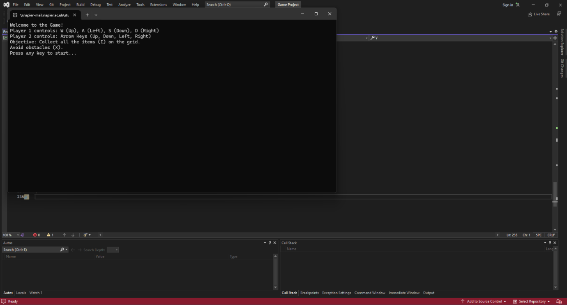
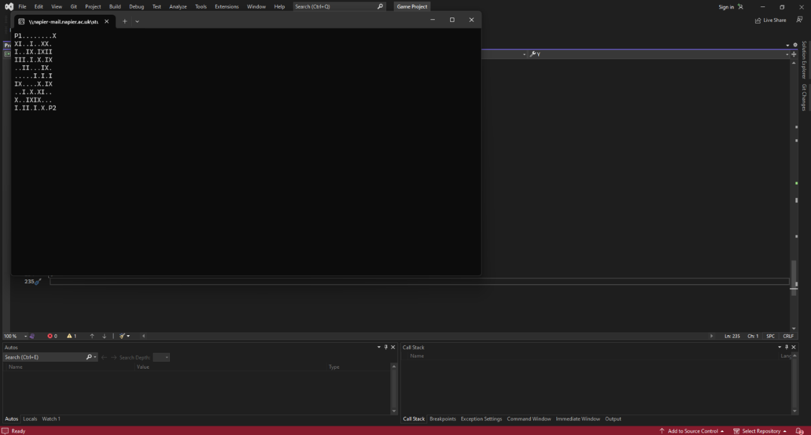
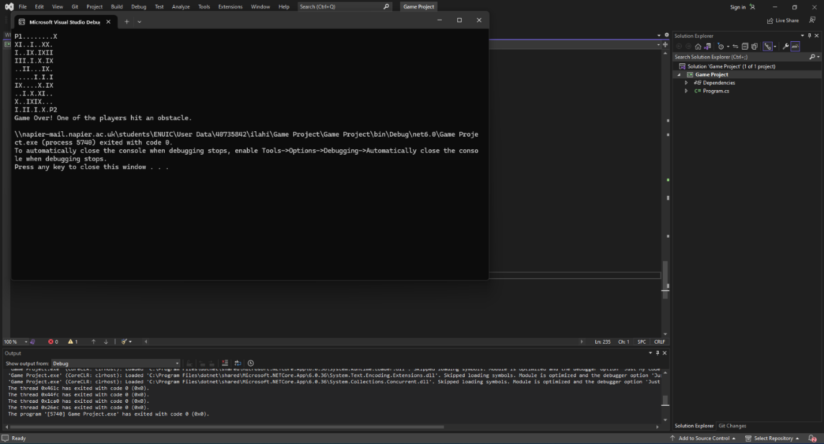
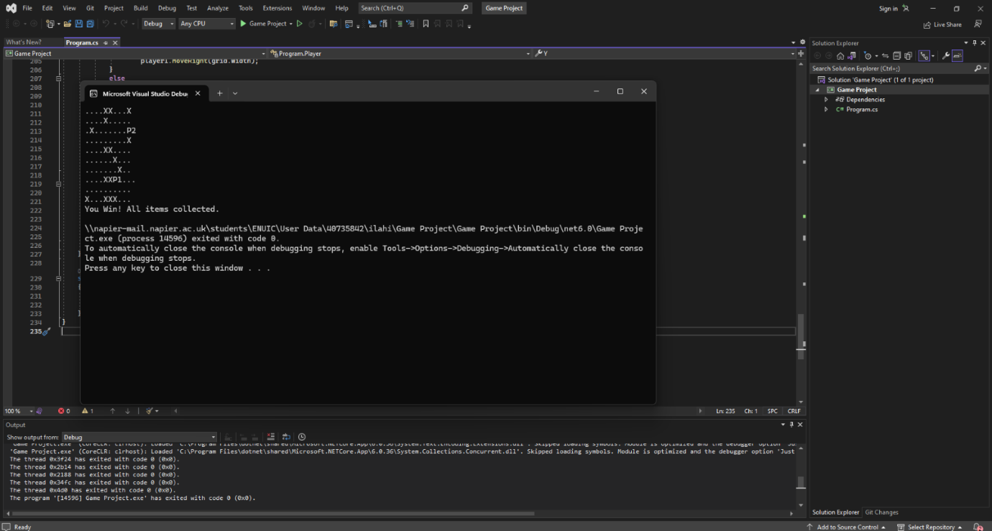
Conditions for Winning and Losing There are two possibilities in this game. Victory is achieved when all the items are collected. When a player hits a barrier, CheckWin() equals true while CheckCollision() also equals true.

